EMBRACE

Who we are
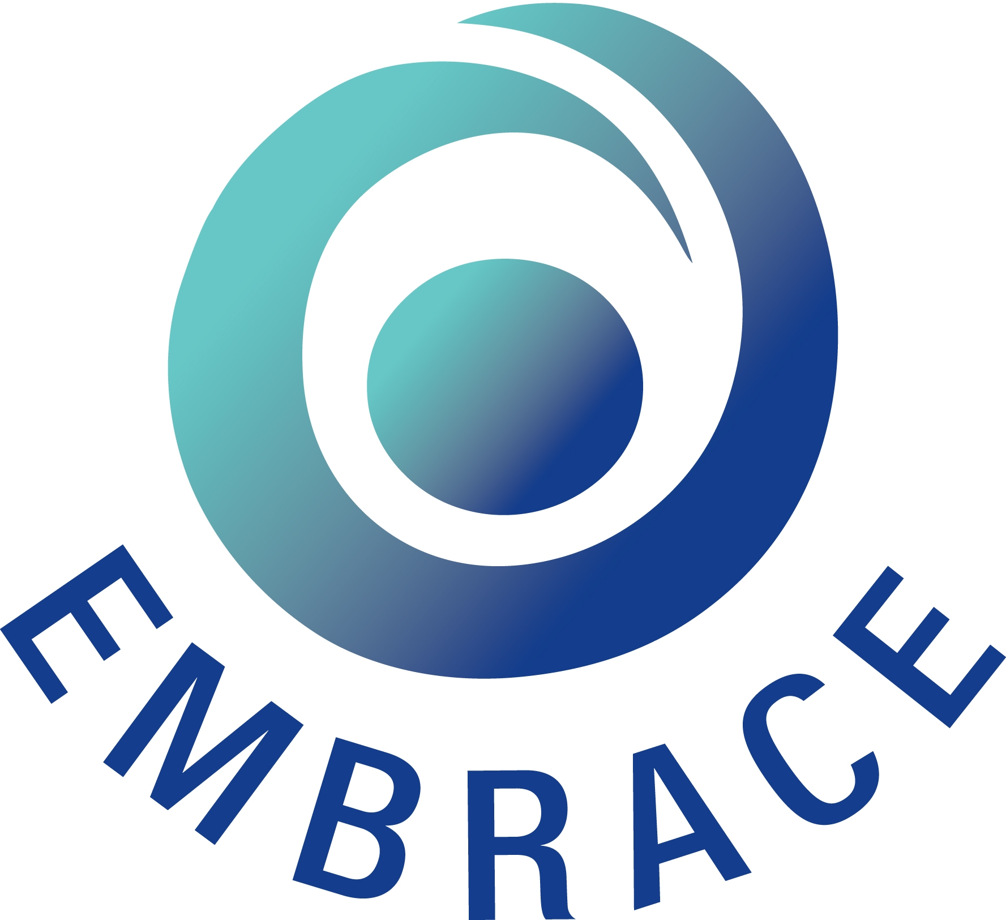
EMBRACE is a group of Christians from different denominations working together to promote a positive response to people who are seeking asylum, refugees, migrant workers and people from minority-ethnic backgrounds living in Northern Ireland. EMBRACE was launched in 2003 and has been a formally recognised charity since 2006.

What we do

Our primary role is to resource Churches through information and training so that they can help make this a more hospitable place for migrant and minority-ethnic people. We also provide information and resources more broadly through the community, provide financial support and practical assistance to people in need, and encourage advocacy where relevant and appropriate.

What we offer churches

Information and Resources

Posters, DVDs, information sheets, English language class details, upcoming events, language cards, materials to guide prayer, advice for churches on sign posting minority-ethnic people in crisis. All resources are free and available from the EMBRACE office. Most resources can also be downloaded from our website (www.embraceni.org).


Awareness raising events and workshops
To provide information and encourage discussion, these can be broadly themed or specific to issues such as migration, asylum, or racism

‘Small World’ Café ~ An introduction to cultures in NI (15 – 24 people)
‘Small Worlds’ are cafe-style events in which people circulate around tables hosted by volunteers from different nationalities. The workshops introduce a taste of the diversity that exists in NI and provide safe space in which participants can engage with those from different backgrounds and other parts of the world.
The conversations take place in a safe and semi-structured setting that is carefully managed by a facilitator.
Currently this is provided through the South Belfast Roundtable and availability is limited due to funding.
Migration and Us: Migration Awareness (15 – 20 people)
This 2 hour interactive training session explores inward and outward migration and provides information on the rights and entitlements of migrant workers in N Ireland. It aims to dispel myths and provide practical information on issues relating to migration.
Seeking Refuge: Refugee Awareness (15 – 40 people)
A 2 hour interactive event which looks at the facts around numbers, why asylum seekers come, where they come from and what happens when they arrive in Northern Ireland seeking refuge.

Talks (For any size of group)

An EMBRACE representative can share a reflection on welcome and migration issues, for different church groups.


A channel for support
EMBRACE provides a means for churches to provide goods and funding for migrant people with no recourse to public funds and refugees in need. EMBRACE seeks to respond to gaps in provision for destitute asylum seekers and migrants. This support is only provided through organisations which work directly with such groups. Currently we provide support for Syrian Vulnerable Persons Resettlement Scheme refugees to meet needs not met in the government package of care. We also help refugees as they set up their first home, with funding towards essentials such as fuel.

Please note that at present we have less capacity to deliver activities and welcome opportunities to work with several churches or church groups together.

